4237582 - Note format preservation across interfaces
Note format preservation across interfaces (Epic 4237582)1. Customer Problem(line breaks, bullets) is lost or inconsistent between EM UI, reports, and add-ins, hurting clarity.
2. Customer Researchrequest for cohesive formatting across surfaces.
3. Our SolutionNormalize note rich-text model and rendering across clients.
- Add tests for bullets, lists, whitespace, and encoding.
Dependencies: FE renderers, report engine, add-in components.
4. Product MetricsFormatting defect rate on notes: -80%.
- Consistency audit pass rate: 100%.
Appendix: Child Features4237583 Notes list Bottom Splitter Pane Format Preservation
- 4237584 Format Preservation in Reports
Appendix: LinksHYPERLINK "https://dev.azure.com/tr-tax/TaxProf/_workitems/edit/4237582"Open Epic 4237582

Appendix: Quick prototype
Figure: PDF page 1
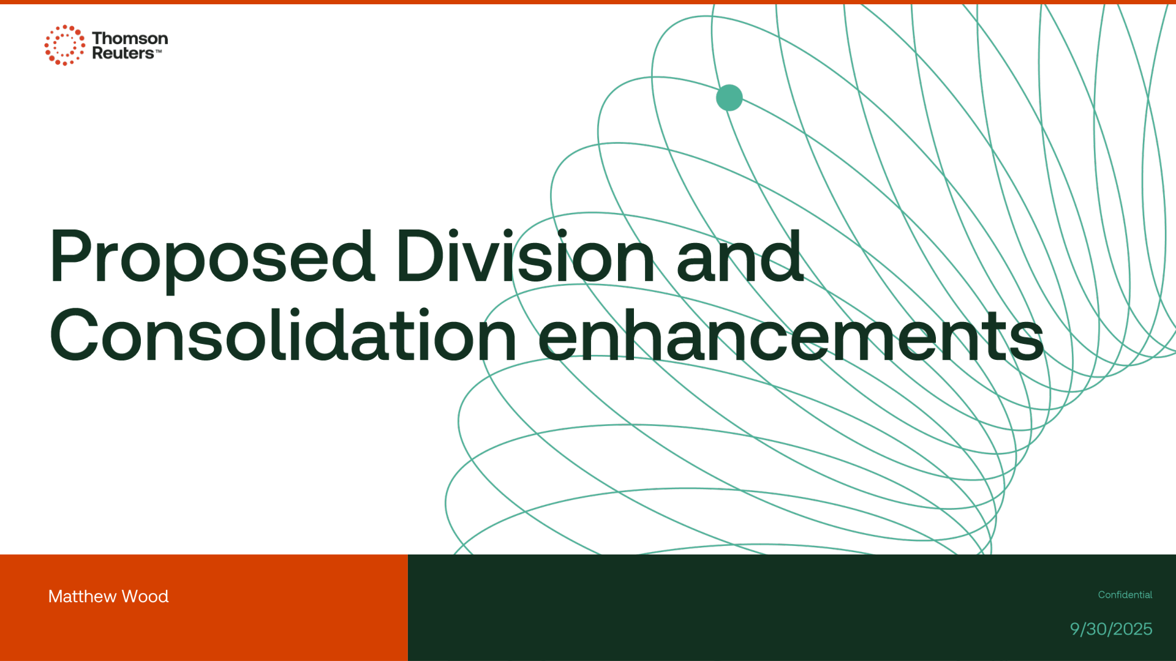

Appendix: Links
ADO Epic Link: https://dev.azure.com/tr-tax/TaxProf/_workitems/edit/4237582

